**Final Submission Agile Report**

# Client Meetings

Below are the meetings we have had with our client for the project, Dr Hannes Hermann.

## Client Meeting 1 (17/03/2022)

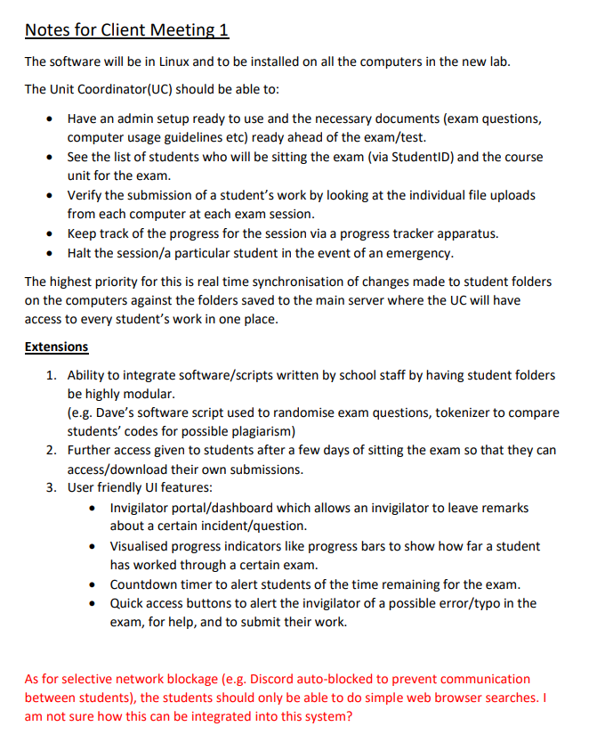

## Client Meeting 2 (23/03/2022)

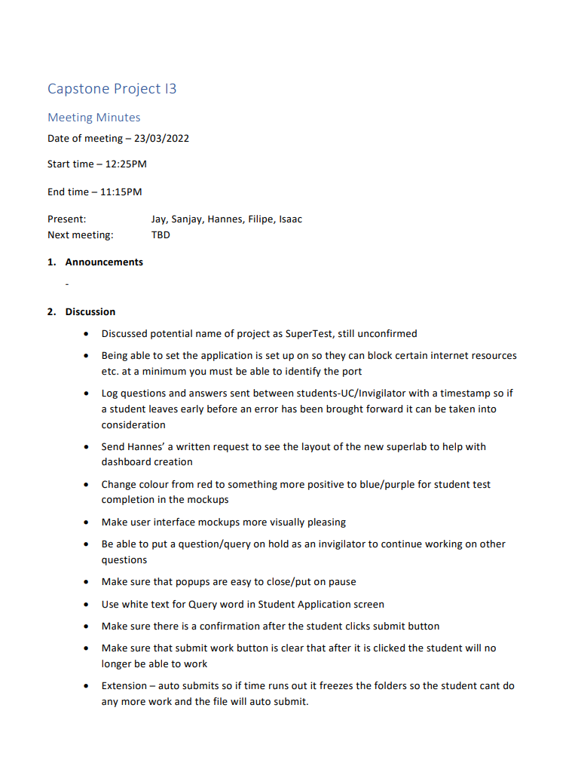

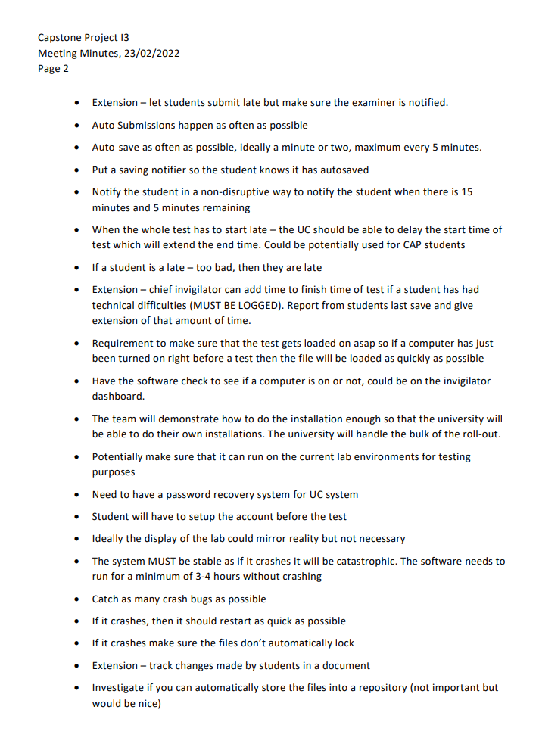

## Client Meeting 3 (13/04/2022)

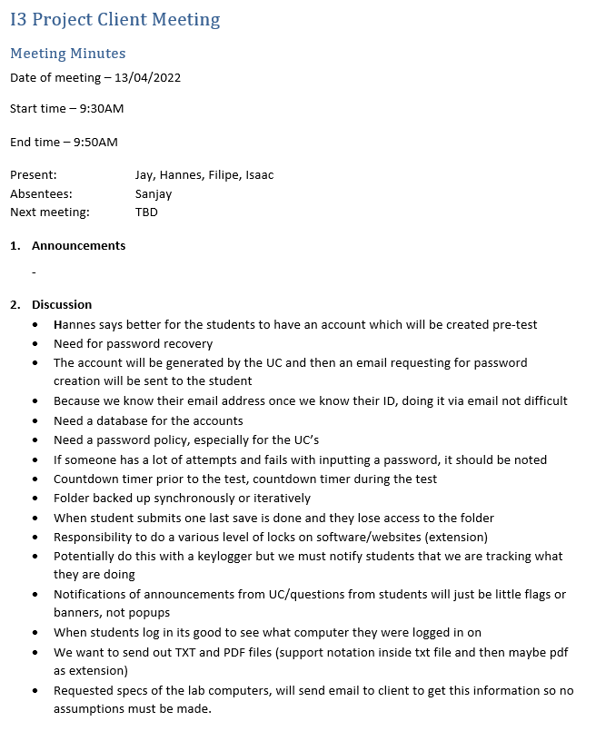

## Client Meeting 4 (11/05/2022)

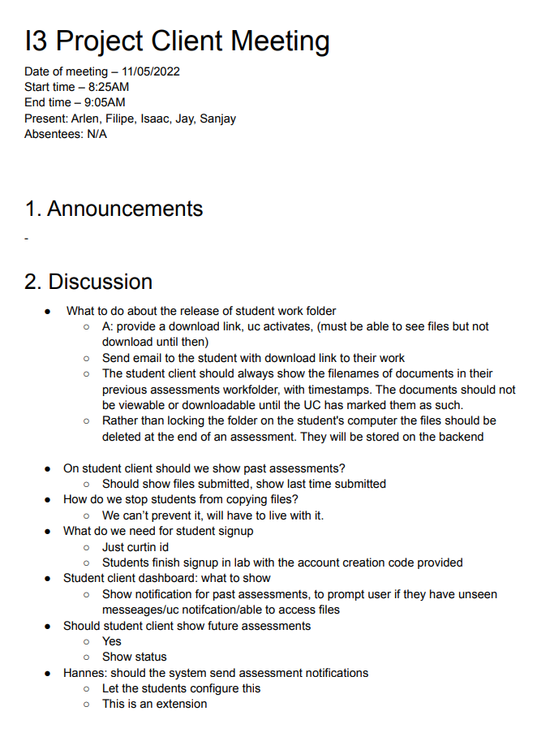

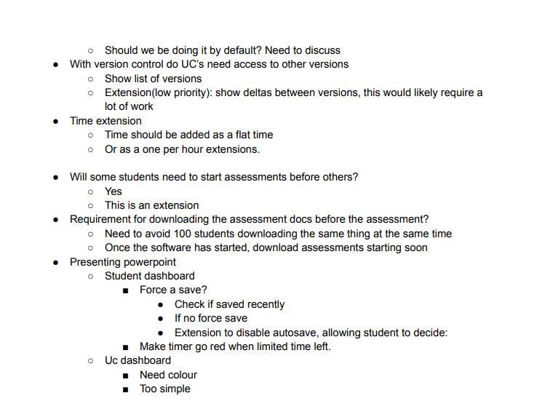

The link to the folder containing the meeting minutes is [here](https://drive.google.com/drive/folders/17HZw_A52e-6iRa6nGGR4s2cM34NeA0RM?usp=sharing).

## Summary

Most of the meetings were done in-person, with the one on 11th of May done online via Microsoft Teams voice chat. The meetings were held in order to garner useful feedback from the client to grasp a better understanding on what is needed for the submission on each sprint and to fix the mistakes we have made for the submissions of the previous sprints.

# 

# Group Communication

Our group communicated continuously throughout the semester in person and online via Discord. We also had regular meetings that allowed us to complete each milestone in a structured and orderly manner.

## Sprint Planning

At the start of each milestone, our group ran a sprint planning meeting which we used to discuss tickets and vote on their length in story points. This process was conducted online using Discord, [www.planitpoker.com](http://www.planitpoker.com) and Trello.

## Standup and Progress Meetings

During Milestones, the group found it helpful to conduct meetings, on Discord, to discuss tickets in our current sprint. These discussions would largely centre around

* Challenges in tickets being undertaken
* Personal time constraints, such as Social commitments or other assignments
* The addition of new tickets
* The assignment remaining tickets

## Post and Pre Supervisor/Client Meetings

Before meeting with Supervisors or Clients the group would often meet, on Discord, to discuss the nature of the meeting. These discussions were used to discuss what questions we were going to ask in the meeting. After the supervisor and client meetings, the group would meet in person or online to discuss the meeting and create actionable tasks from the meeting minutes.

## Discord

Discord was the primary tool for our meetings. We also used the tool to send messages within the group. Discord messages were sent frequently within our group to organise meetings, discuss tickets, ask questions and provide updates.

## Evidence

Sprint Planning Voting was conducted on PlanitPoker. Below are several csv files generated by the software

* [Milestone 4 planning](https://drive.google.com/file/d/1h_WW8wLWPQ7aNKI28wk3lYRraNa4dSOZ/view?usp=sharing)
* [Milestone 5 planning](https://drive.google.com/file/d/1br6bGO7tzHpV8tR8H8KilaLWiJjrM1Ow/view?usp=sharing)
* [Semester 2 planning](https://drive.google.com/file/d/1zZIU8nR22RPBL712jd4eLrHvDMOyadWf/view?usp=sharing)

Below is a screenshot of our discord group (with the messages blurred out)

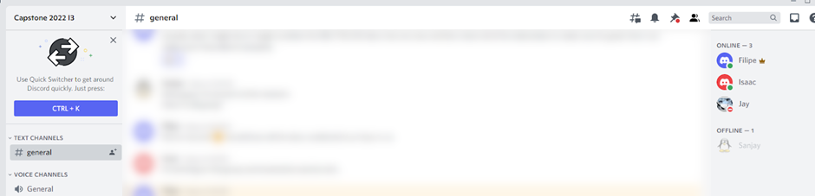

Meeting Minutes

* [14/3 meeting minutes](https://docs.google.com/document/d/1xjjmh4GB2rqGGAa-vu3rkb1JzYmaA1Ho/edit?usp=sharing&ouid=101201731502612759116&rtpof=true&sd=true)

Trello

* This semester our group logged a total 52 hours and 49 minutes of time spent on Meetings. Part of which was for group meetings and sprint planning.

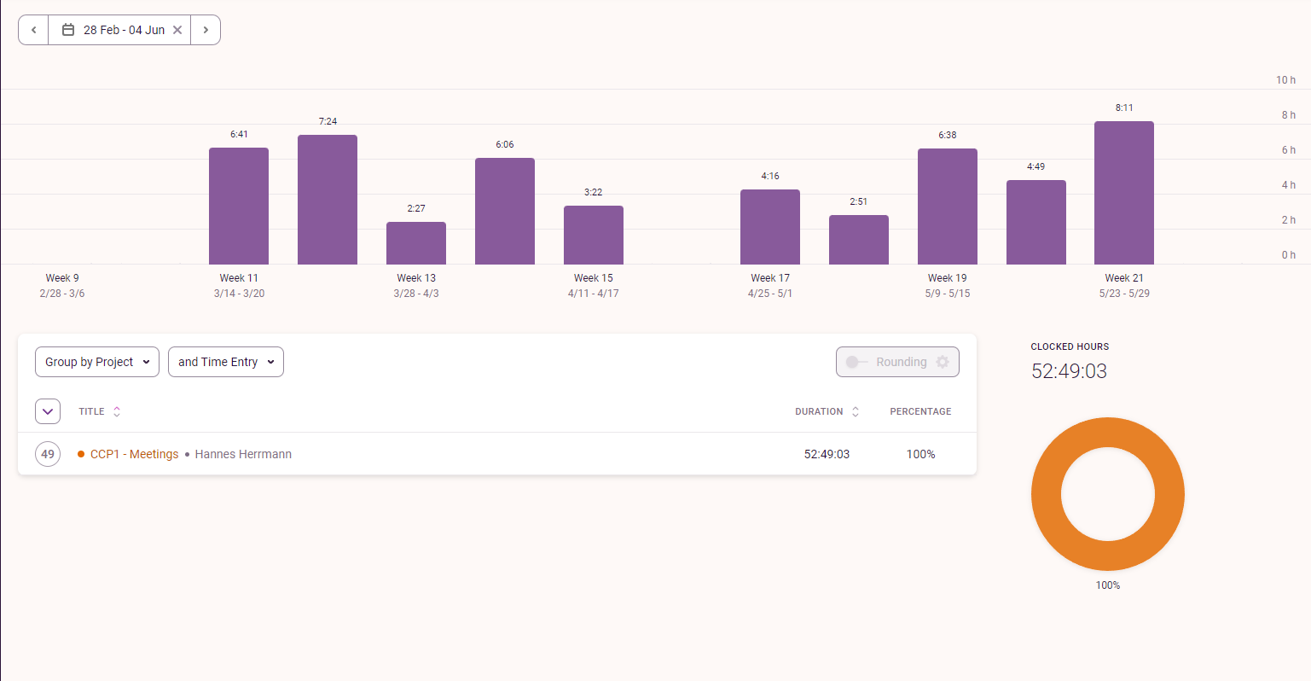

* We also logged a total of 10 hours and 13 minutes on Pre/Post meetings tasks. Part of which involved group meetings.

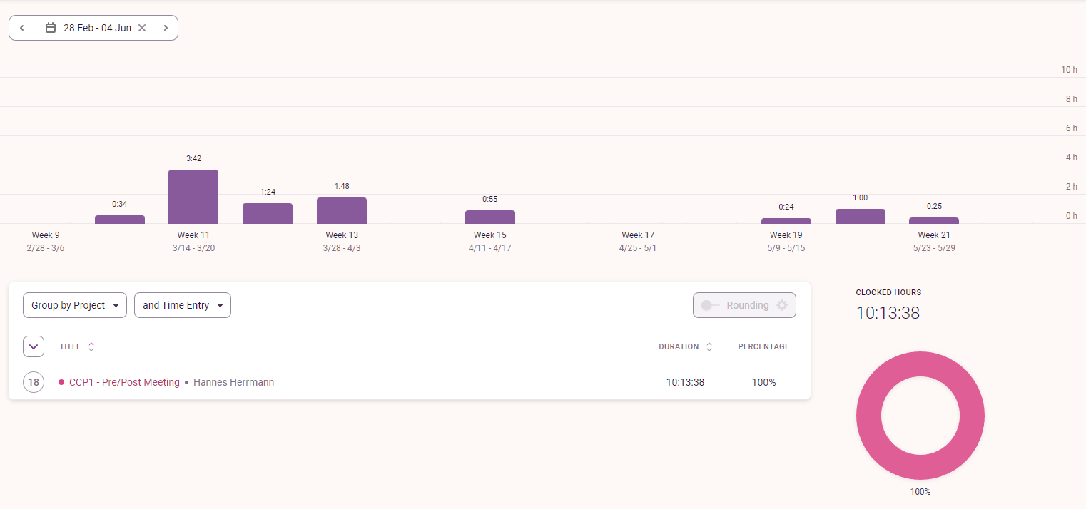

## Summary

Our group communicated consistently throughout the semester. This communication took the forms of meetings, online messaging and in-person discussion. Our communication allowed our group to work cohesively together on each Milestone and Project.

# 

# Progress Tracking

Our group ensured that each sprint was planned out with a list of tickets and an estimated amount of time that each ticket would take. Progress was then tracked through the use of a kanban-style board. Each individual also logged all of their hours worked on toggl. The combination of these elements meant that the team knew where all other members were in terms of completion of their assigned tasks.

## Evidence

### Kanban Board

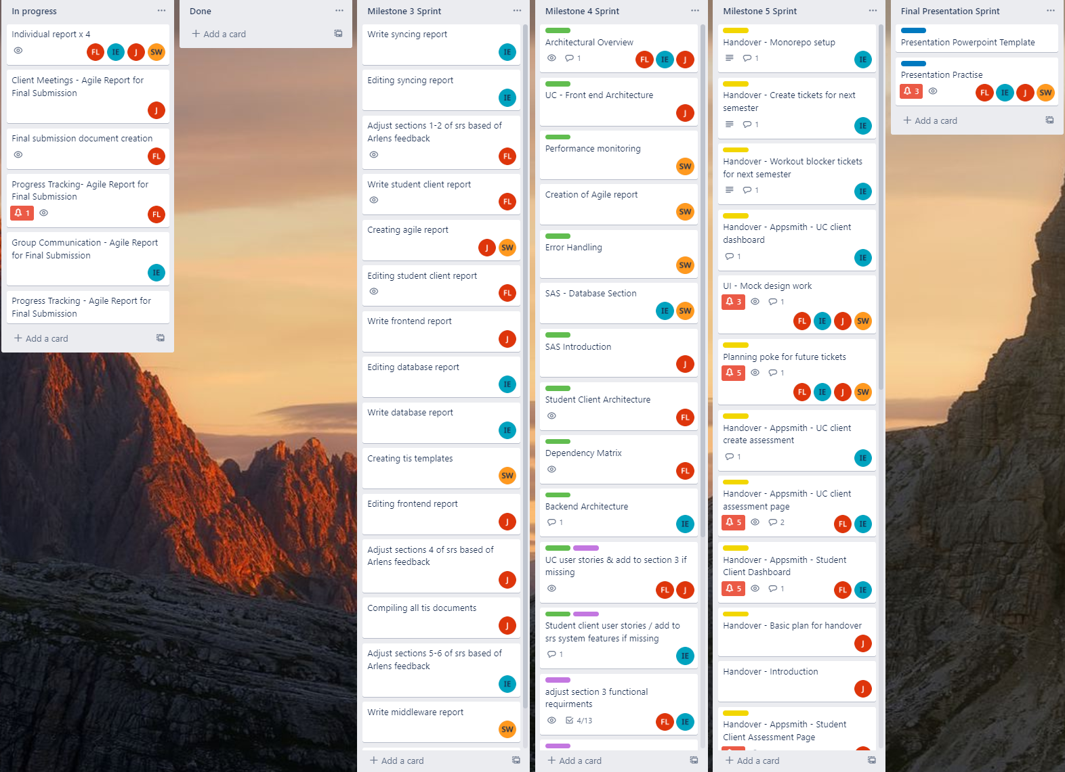

The above board shows all tickets for each sprint (from milestone 3 onwards as that is when it was put in place). During the sprint they are in the in progress section and moved to the done section. Once the milestone has been completed the tickets are moved to a separate list to keep track of what has been done.

Toggl Reports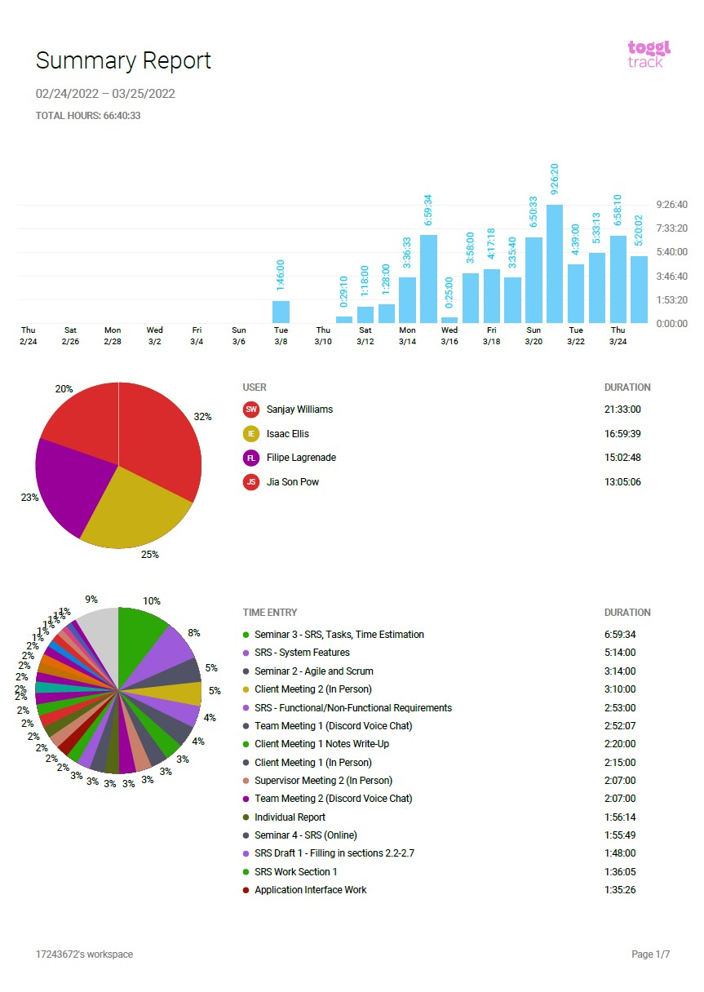

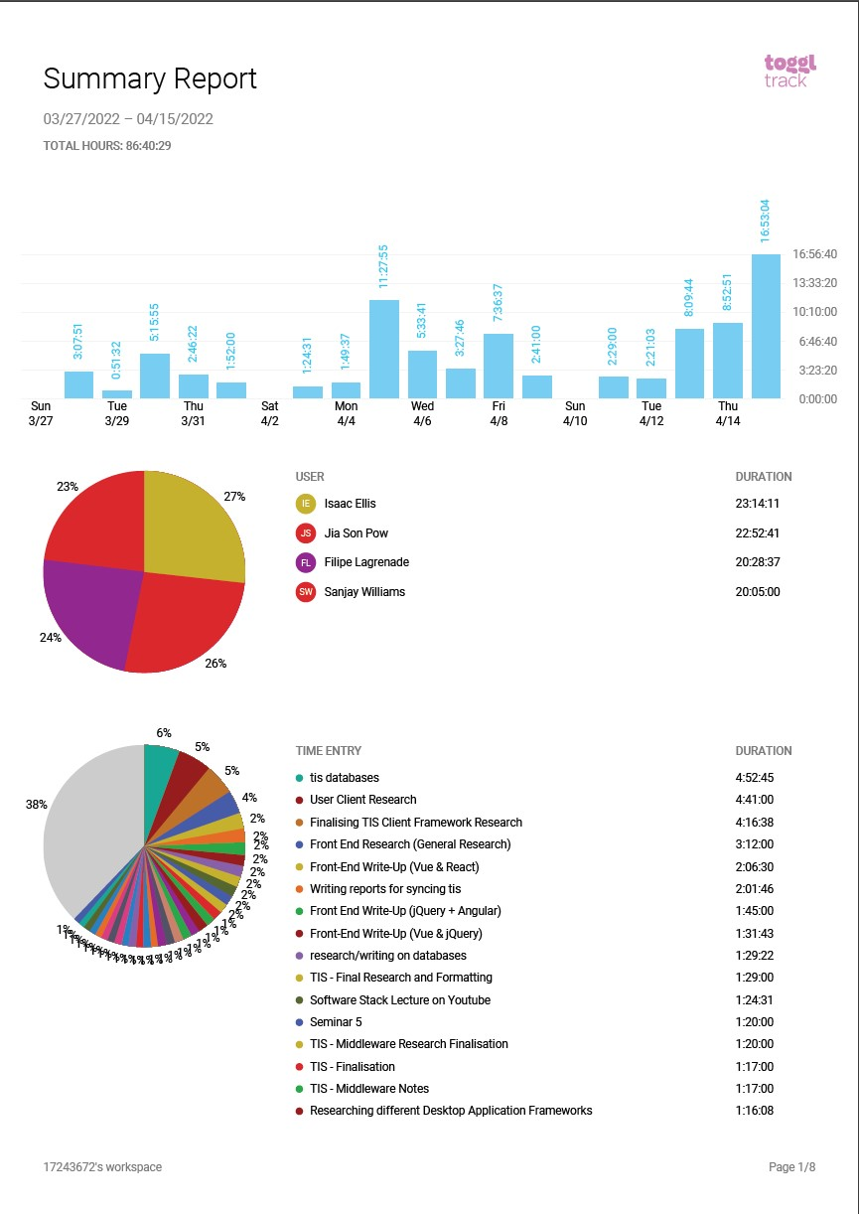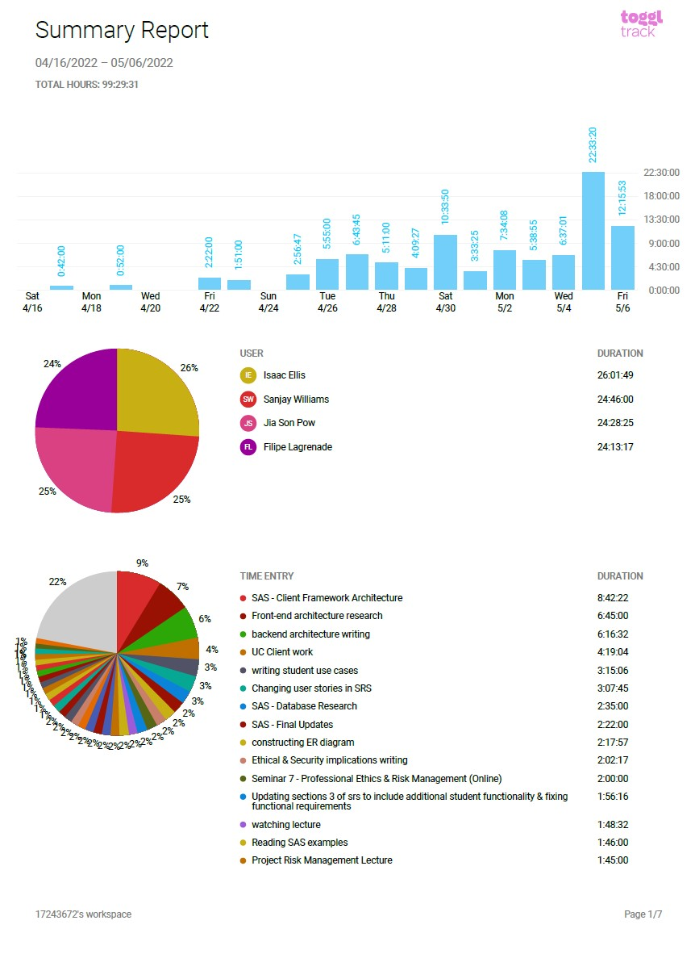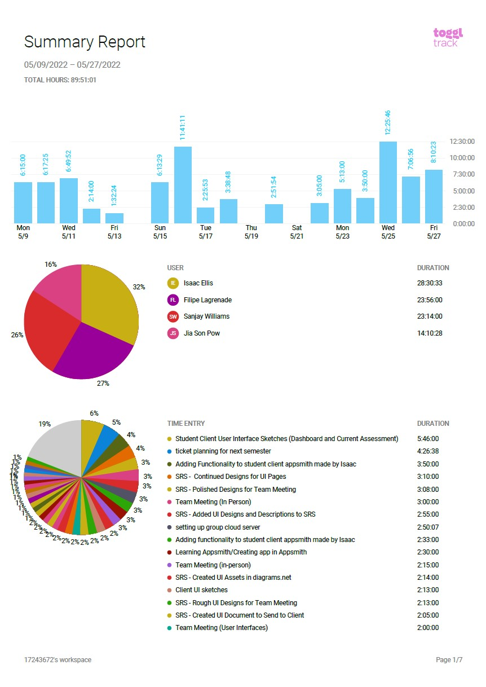The above reports show the toggl summaries for the SRS, TIS, SAS and Handover milestones respectively.

### Burndown Charts

TIS

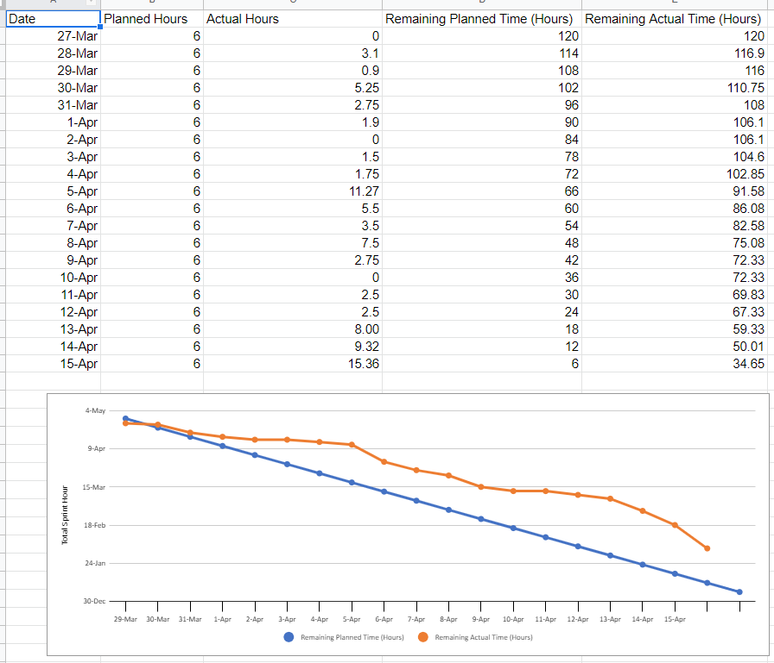

SAS

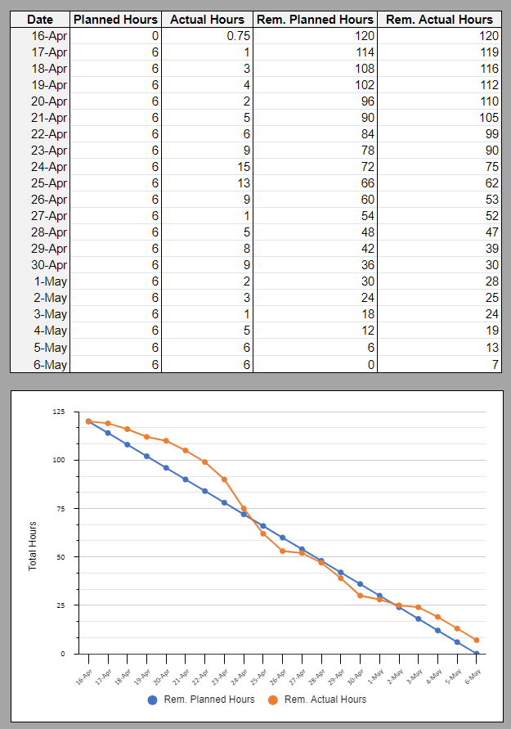

Handover

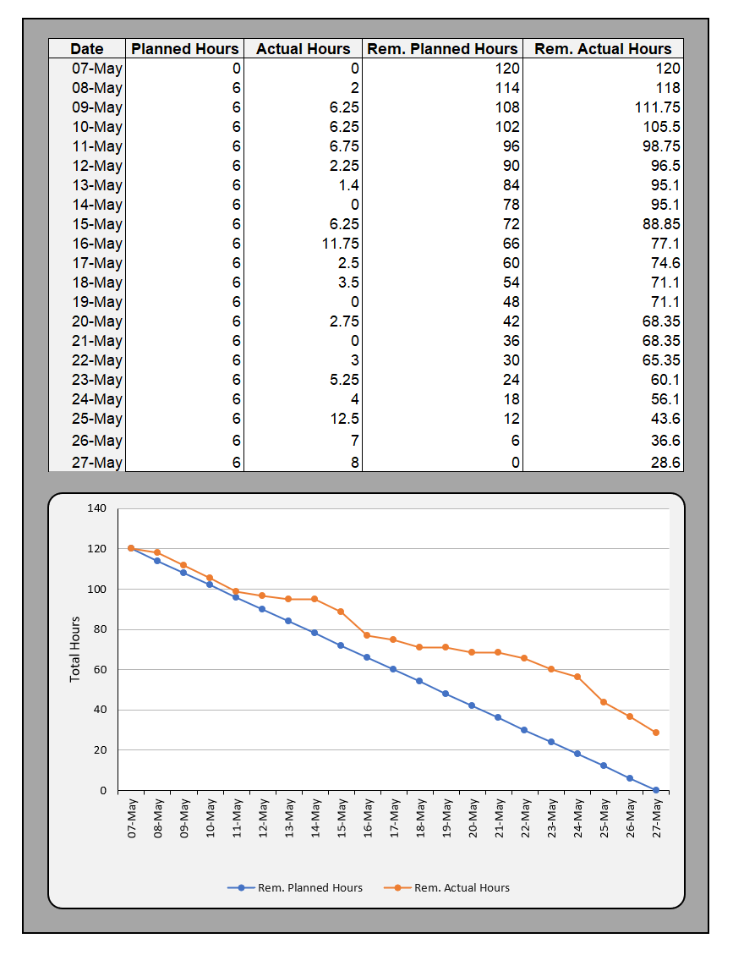

The above 3 images show burndown charts for each sprint. These charts demonstrate that progress was on track for the above sprints.

## Summary

Our group was able to maintain progress throughout the semester through the use of a kanban board, planning poker, toggl tracking and burndown charts.